**Pf assignment 2 code and screenshots**

**Roll num: 25k-0067**

Q5 result ss

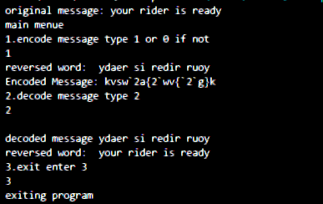

Code

#include<stdio.h>

#include <string.h>

void reversal(char str[])

{

int size=strlen(str);

for (int i = 0; i < size/2; i++)

{

char temp = str[i];

str[i] = str[size - i - 1];

str[size - i - 1] = temp;

}

printf("reversed word:  %s", str);

}

  void encodeMessage(char str[]) {

    for (int i = 0; str[i] != '\0'; i++) {

        unsigned char ch = str[i];

        ch = ch ^ (1 << 1);

        ch = ch ^ (1 << 4);

        str[i] = ch;

    }

  }

  void decode(char str[]){

    for (int i = 0; str[i] != '\0'; i++) {

        unsigned char ch = str[i];

        ch = ch ^ (1 << 4);

        str[i] = ch;}

        }

 #include<stdio.h>

int main(){

    int choice;

    char str[]="your rider is ready";

     printf("original message: %s\n", str);

    printf("main menue\n");

    printf("1.encode message type 1 or 0 if not\n");

    scanf("%d", &choice);

    if (choice==1)

    {

        reversal(str);

        encodeMessage(str);

         printf("\nEncoded Message: %s\n", str);

    }

    printf("2.decode message type 2\n");

    scanf("%d", &choice);

if (choice==2)

    {

        decode(str);

         printf("\ndecoded message %s\n", str);

         reversal(str);

    }

    printf("\n3.exit enter 3\n");

    scanf("%d", &choice);

    if (choice==3)

    {

        printf("exiting program\n");

    }

return 0;

}

Q3.

Result ss;

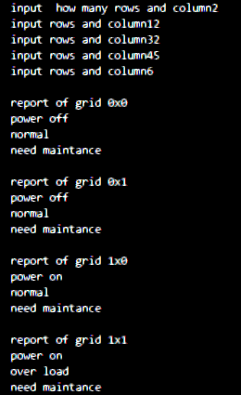

Code

#include<stdio.h>

void check(int n,int arr[n][n],int power,int load,int maintence){

    for (int i = 0; i < n; i++)

{

    for (int j = 0; j < n; j++)

    {

       int d = arr[i][j];

       if (d&1==1)

       {

        power =1;

       }

       else if (d&1==0)

       {

        power =0;

       }

         else if  ((d & (1 << 1)) == (1 << 1))

       {

        load =1;

       }

         else if  ((d & (1 << 1)) == (1 << 1))

       {

        load =0;

       }

           else if  ((d & (1 << 2)) == (1 << 2))

       {

        maintence =1;

       }

         else if  ((d & (1 << 2)) == (1 << 2))

       {

        maintence =0;

       }

      printf("\nreport of grid %dx%d\n",i,j);

       if (power==1)

       {

        printf("power on\n");

       }

         if (power==0)

       {

        printf("power off\n");

       }  if (load==1)

       {

        printf("over load\n");

       }  if (load==0)

       {

        printf("normal\n");

       }  if (maintence==1)

       {

        printf("need maintance\n");

       }

         }  if (maintence==0)

       {

        printf("no need of maintance\n");

       }

    }

}

int main(){

int n=0;

int power=0;

int load=0;

int maintence=0;

printf("input  how many rows and column");

scanf("%d", &n);

int arr[n][n];

for (int i = 0; i < n; i++)

{

    for (int j = 0; j < n; j++)

    {

        printf("input rows and column");

       scanf("%d", &arr[i][j]);

    }

}

check (n,arr,power,load,maintence);

return 0;

}

Q2 screenshot

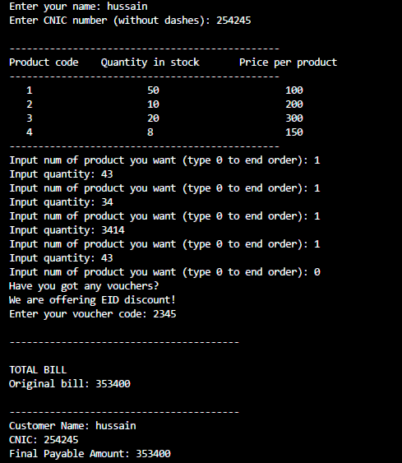

Code

#include <stdio.h>

#include <string.h>

int input(char name[], char cnic[]) {

    printf("Enter your name: ");

    scanf(" %[^\n]", name);

    printf("Enter CNIC number (without dashes): ");

    scanf("%s", cnic);

    return 0;

}

int main() {

    printf("Product code\n");

    int code = 0;

    int flag = 1;

    int quantity = 0;

    int bill = 0;

    int total = 0;

    int voucher = 0;

    char name[50];

    char cnic[20];

    input(name, cnic);

  int arr[4][3] = {

    {1, 50, 100},

    {2, 10, 200},

    {3, 20, 300},

    {4, 8, 150}

};

printf("\n-----------------------------------------------\n");

printf("Product code\tQuantity in stock\tPrice per product\n");

printf("-----------------------------------------------\n");

for (int i = 0; i < 4; i++) {

    for (int j = 0; j < 3; j++) {

        if (j == 0)

            printf("   %d\t\t\t", arr[i][j]);

        else

            printf("%d\t\t\t", arr[i][j]);

    }

    printf("\n");

}

printf("-----------------------------------------------\n");

    while (1) {

        printf("Input num of product you want (type 0 to end order): ");

        scanf("%d", &code);

        if (code == 0) {

            flag = 0;

            break;

        }

        printf("Input quantity: ");

        scanf("%d", &quantity);

        if (code == 1) {

            arr[0][1] -= quantity;

            bill = quantity * arr[0][2];

            total += bill;

        } else if (code == 2) {

            arr[1][1] -= quantity;

            bill = quantity * arr[1][2];

            total += bill;

        } else if (code == 3) {

            arr[2][1] -= quantity;

            bill = quantity * arr[2][2];

            total += bill;

        } else if (code == 4) {

            arr[3][1] -= quantity;

            bill = quantity * arr[3][2];

            total += bill;

        } else {

            printf("Invalid product code!\n");

        }

    }

    if (flag == 0) {

        printf("Have you got any vouchers?\n");

        printf("We are offering EID discount!\n");

        printf("Enter your voucher code: ");

        scanf("%d", &voucher);

        if (voucher == 2334) {

            printf("\nYou have availed your discount of 25%%");

            printf("\n----------------------------------------\n");

            printf("\nTOTAL BILL\n");

            printf("Original bill: %d\n", total);

            printf("After discount: %.2f\n", total * 0.75);

        } else {

            printf("\n----------------------------------------\n");

            printf("\nTOTAL BILL\n");

            printf("Original bill: %d\n", total);

        }

        printf("\n----------------------------------------\n");

        printf("Customer Name: %s\n", name);

        printf("CNIC: %s\n", cnic);

        printf("Final Payable Amount: %d\n", total);

    }

    return 0;

}

Q1;

Ss

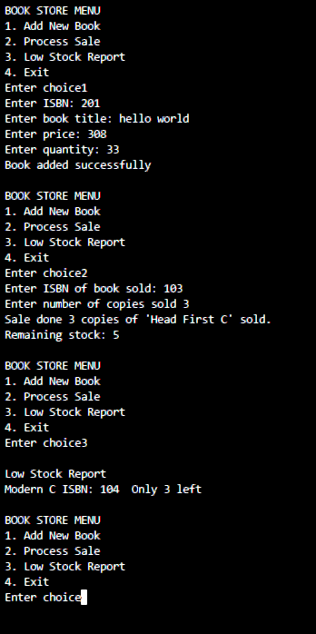

Code

#include <stdio.h>

#include <string.h>

void addBook(int isbns[100], char titles[100][50], int prices[100], int quantities[100], int *n) {

    int newIsbn;

    printf("Enter ISBN: ");

    scanf("%d", &newIsbn);

    // Check duplicate ISBN

    for (int i = 0; i < *n; i++) {

        if (isbns[i] == newIsbn) {

            printf("Error: ISBN already exists\n");

            return;

        }

    }

    isbns[*n] = newIsbn;

    printf("Enter book title: ");

    scanf(" %[^\n]", titles[*n]);  // read full line

    printf("Enter price: ");

    scanf("%d", &prices[*n]);

    printf("Enter quantity: ");

    scanf("%d", &quantities[*n]);

    (*n)++;

    printf("Book added successfully\n");

}

void processSale(int isbns[100], char titles[100][50], int prices[100], int quantities[100], int n) {

    int searchIsbn, sold;

    printf("Enter ISBN of book sold: ");

    scanf("%d", &searchIsbn);

    int found = -1;

    for (int i = 0; i < n; i++) {

        if (isbns[i] == searchIsbn) {

            found = i;

            break;

        }

    }

    if (found == -1) {

        printf("Error: Book not found.\n");

        return;

    }

    printf("Enter number of copies sold ");

    scanf("%d", &sold);

    if (quantities[found] < sold) {

        printf("Error Not enough stock for '%s'.\n", titles[found]);

    } else {

        quantities[found] -= sold;

        printf("Sale done %d copies of '%s' sold.\n", sold, titles[found]);

        printf("Remaining stock: %d\n", quantities[found]);

    }

}

void lowStockReport(int isbns[100], char titles[100][50], int prices[100], int quantities[100], int n) {

    printf("\nLow Stock Report\n");

    for (int i = 0; i < n; i++) {

        if (quantities[i] < 5) {

            printf("%s ISBN: %d  Only %d left\n", titles[i], isbns[i], quantities[i]);

        }

    }

}

int main() {

    int isbns[100];

    char titles[100][50];

    int prices[100];

    int quantities[100];

    int choice, n = 5;

    isbns[0] = 101; strcpy(titles[0], "C Programming");

    isbns[1] = 102; strcpy(titles[1], "Learn C Fast");

    isbns[2] = 103; strcpy(titles[2], "Head First C");

    isbns[3] = 104; strcpy(titles[3], "Modern C");

    isbns[4] = 105; strcpy(titles[4], "Clean Code in C");

    prices[0] = 450; quantities[0] = 10;

    prices[1] = 399; quantities[1] = 5;

    prices[2] = 295; quantities[2] = 8;

    prices[3] = 492; quantities[3] = 3;

    prices[4] = 420; quantities[4] = 7;

    while (1) {

        printf("\nBOOK STORE MENU\n");

        printf("1. Add New Book\n");

        printf("2. Process Sale\n");

        printf("3. Low Stock Report\n");

        printf("4. Exit\n");

        printf("Enter choice");

        scanf("%d", &choice);

        switch (choice) {

            case 1: addBook(isbns, titles, prices, quantities, &n); break;

            case 2: processSale(isbns, titles, prices, quantities, n); break;

            case 3: lowStockReport(isbns, titles, prices, quantities, n); break;

            case 4: return 0;

            default: printf("Invalid choice. Try again.\n");

        }

    }

}

Q4;

Ss

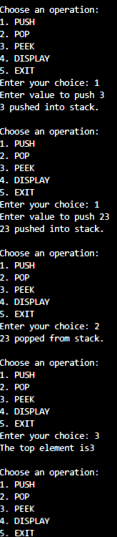

Code

#include <stdio.h>

#define MAX 5

void display(int stack[], int top) {

    if (top == -1) {

        printf("Stack is empty\n");

    } else {

        printf("Stack elements\n");

        for (int i = top; i >= 0; i--) {

            printf("%d\n", stack[i]);

        }

    }

}

void peek(int stack[], int top) {

    if (top == -1) {

        printf("Stack is empty.\n");

    } else {

        printf("The top element is%d\n", stack[top]);

    }

}

void pop(int stack[], int *top) {

    if (*top == -1) {

        printf("Stack Underflow! No elements to pop.\n");

    } else {

        printf("%d popped from stack.\n", stack[*top]);

        (*top)--;

    }

}

void push(int stack[], int *top) {

    int val;

    if (*top == MAX - 1) {

        printf("Stack Overflow \n");

    } else {

        printf("Enter value to push ");

        scanf("%d", &val);

        (*top)++;

        stack[*top] = val;

        printf("%d pushed into stack.\n", val);

    }

}

int main() {

    int stack[MAX];

    int top = -1;

    int choice;

    int flag = 1;

    while (flag) {

        printf("\nChoose an operation:\n");

        printf("1. PUSH\n");

        printf("2. POP\n");

        printf("3. PEEK\n");

        printf("4. DISPLAY\n");

        printf("5. EXIT\n");

        printf("Enter your choice: ");

        scanf("%d", &choice);

        switch (choice) {

            case 1:

                push(stack, &top);

                break;

            case 2:

                pop(stack, &top);

                break;

            case 3:

                peek(stack, top);

                break;

            case 4:

                display(stack, top);

                break;

            case 5:

                flag = 0;

                printf("Exiting program.\n");

                break;

        }

    }

    return 0;

}